LAB ASSIGNMENT-8.3
Name:Ashwitha
Hall ticket:2303A51340
Task 1:
Prompt:
Follow Test Driven Development (TDD).
First generate test cases for valid, invalid, and edge-case email formats.
Requirements: email must contain exactly one '@', include '.', must not start or end with special characters, and must not contain spaces.
Implement is_valid_email(email) so all test cases pass using assertions or unittest.
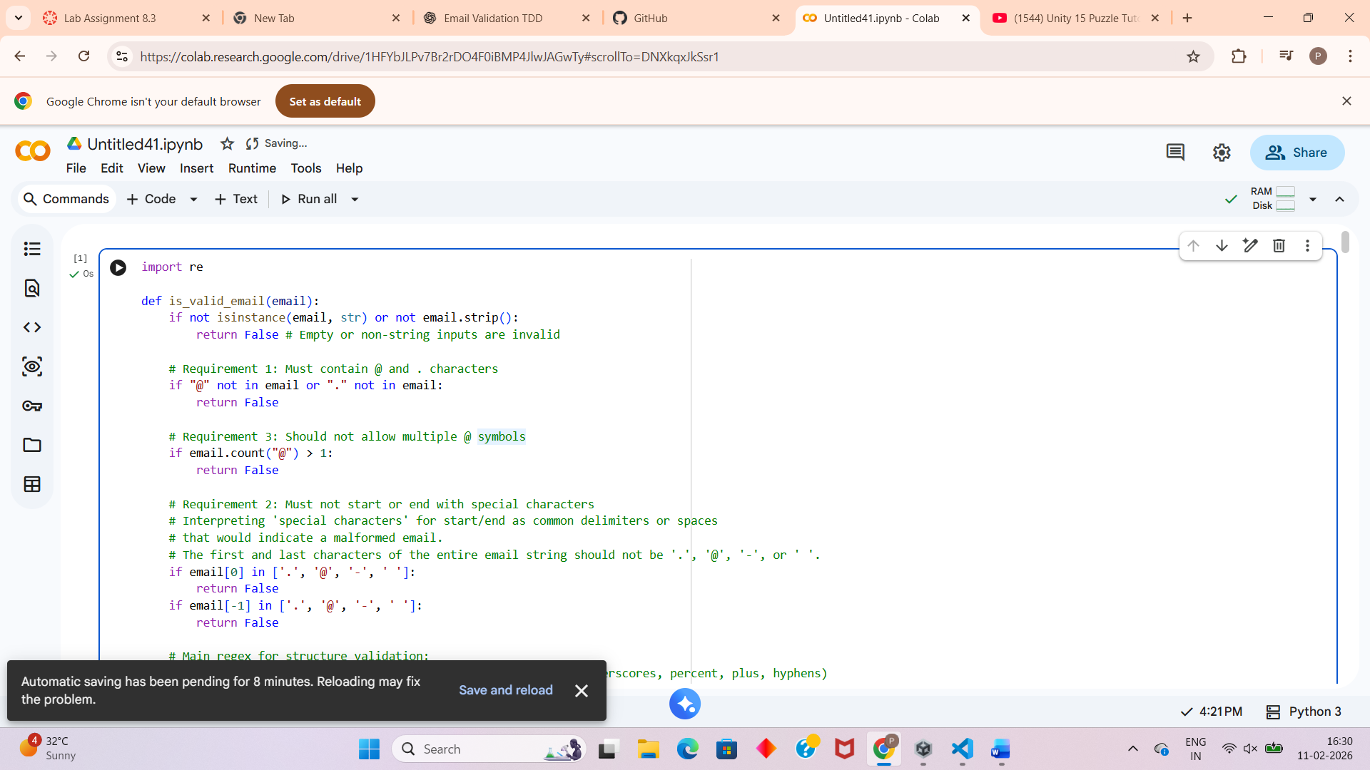
Output:
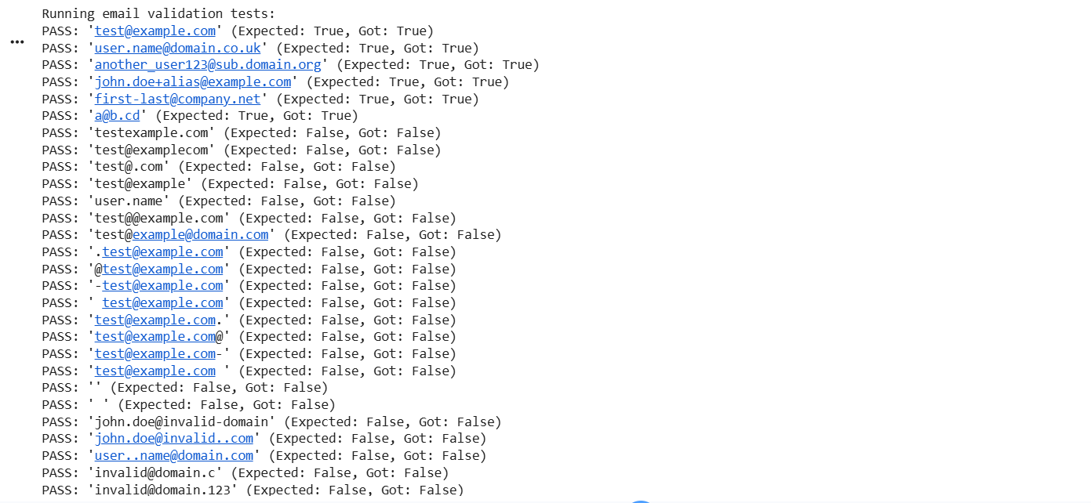
Analysis:
This task validates structured input using rule-based checks. TDD helps ensure incorrect email formats are rejected before implementation.
Task 2:
Prompt:
Follow Test Driven Development (TDD).
Generate test cases for assign_grade(score) including boundary values (60, 70, 80, 90) and invalid inputs (-5, 105, "eighty").
Implement grade logic using loops and ensure all tests pass with correct grade outputs and proper error handling.
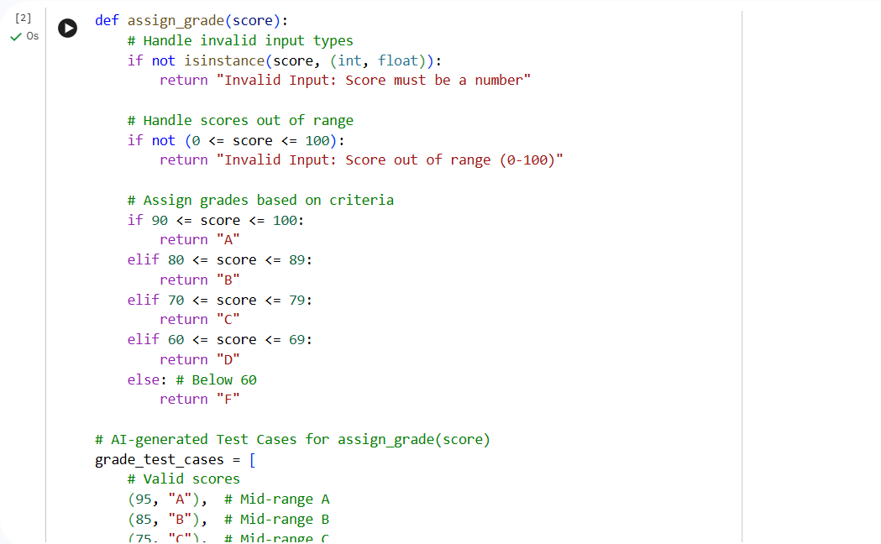
Output:
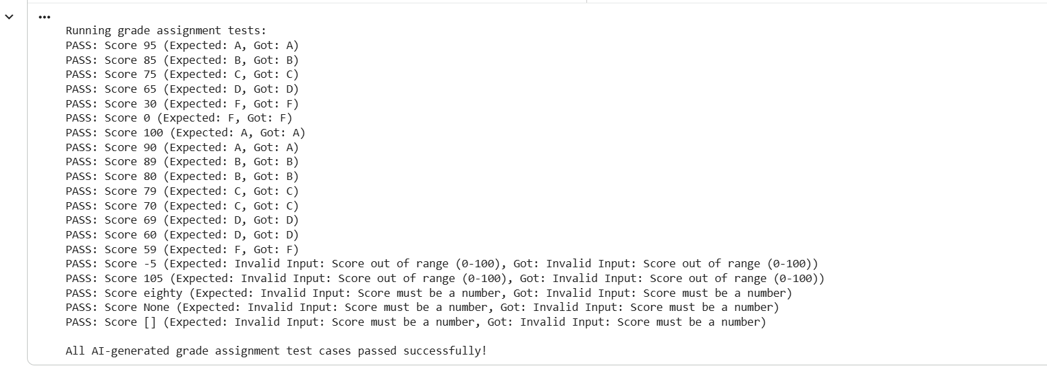
Analysis:
This task focuses on conditional logic and boundary testing. TDD ensures accurate grading and safe handling of invalid inputs.
Task 3:
Follow Test Driven Development (TDD).
Generate test cases for palindromic and non-palindromic sentences.
Ignore case, spaces, and punctuation.
Implement is_sentence_palindrome(sentence) and ensure all generated tests pass.
Analysis:
This task demonstrates text preprocessing. Removing formatting differences allows logical palindrome detection.
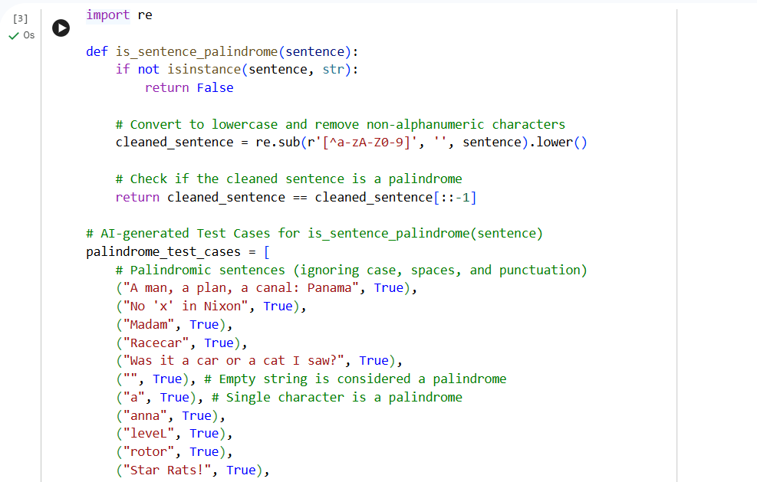
Output:
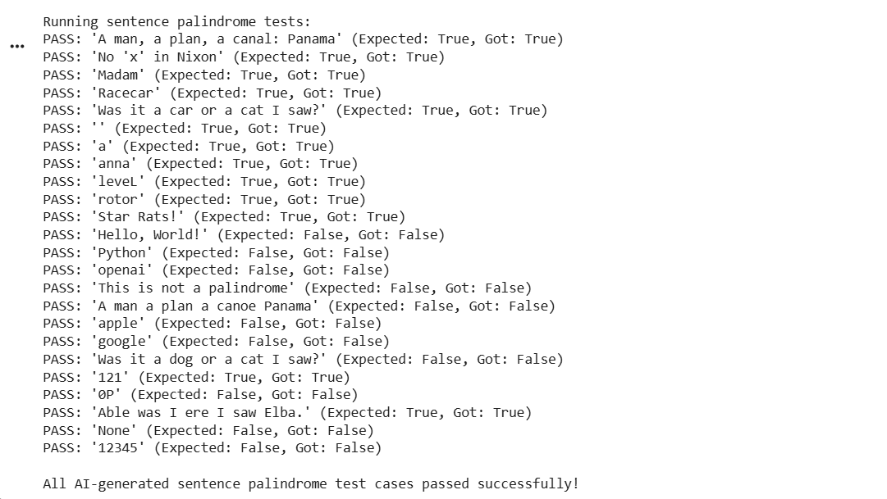
Task 4:
Follow Test Driven Development (TDD).
Generate test cases for adding items, removing items, total cost calculation, and empty cart handling.
Implement a ShoppingCart class with methods add_item, remove_item, and total_cost so all tests pass.
Analysis:
This task applies object-oriented programming concepts and validates class behavior through automated testing.
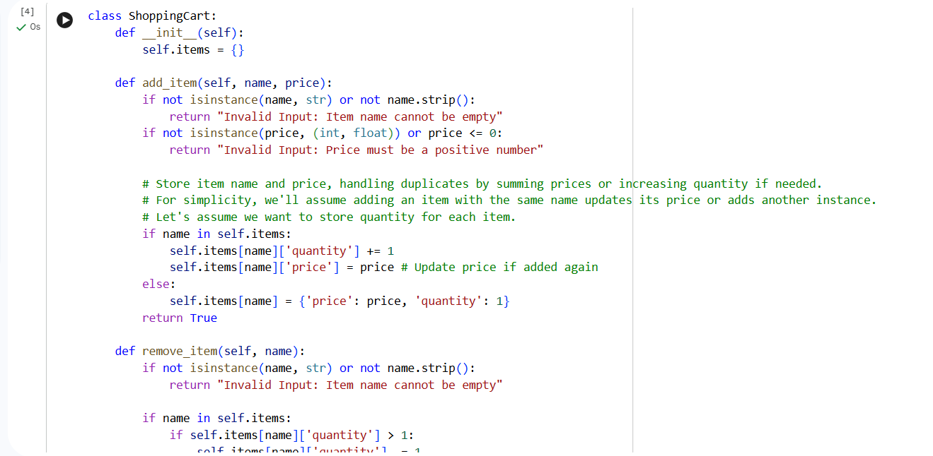
OUTPUT:
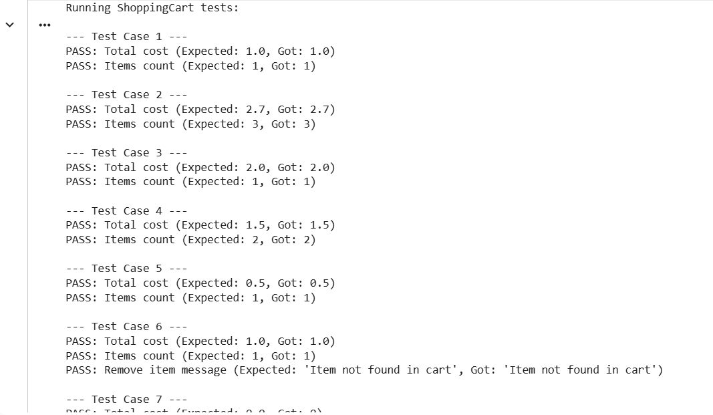
Task 5:
Follow Test Driven Development (TDD).
Generate test cases for valid and invalid date inputs.
Convert date format from "YYYY-MM-DD" to "DD-MM-YYYY".
Implement convert_date_format(date_str) so all tests pass successfully.
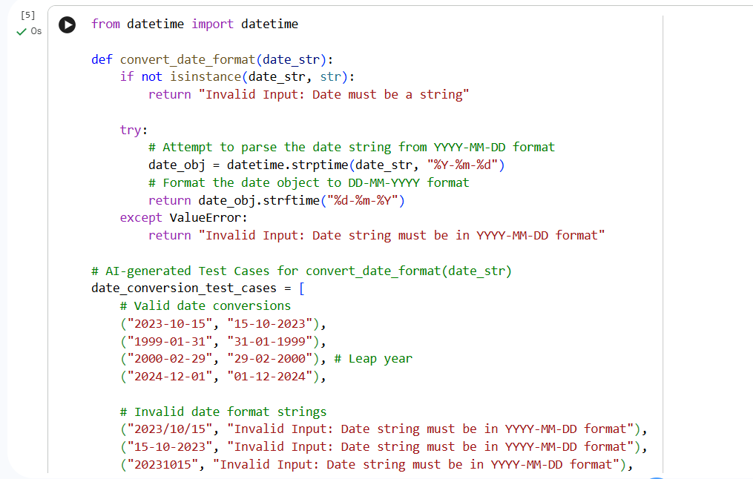
Output:
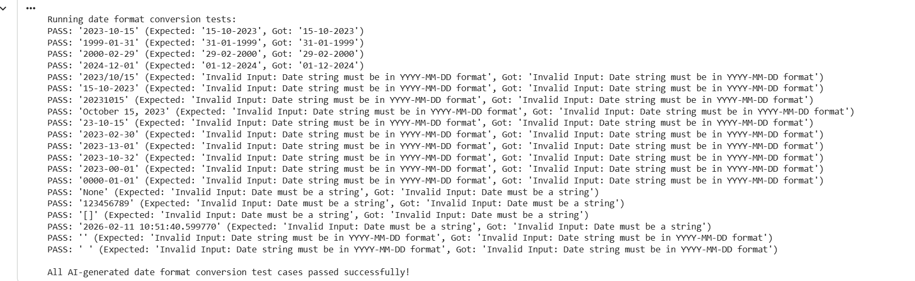
Analysis:
This task focuses on string manipulation and format validation. TDD ensures only correctly formatted dates are converted.

